**Уважаемые студенты, предлагаю вам задания для удаленного обучения по английскому языку. Задания необходимо выполнить в тетради, сделать четкую фотографию и отправить личным сообщением в ВК по ссылке** [**https://vk.com/a.vashutina**](https://vk.com/a.vashutina) **до 06 ноября включительно. Работы, присланные позже, рассматриваться и приниматься не будут. В сообщении четко указать свои Фамилию, Имя, курс.**

**ENGLAND IS FAMOUS FOR ITS WRITERS AND POETS, BUT DID YOU KNOW ENGLAND IS ALSO A COUNTRY OF INVENTORS? MANY OF THE THINGS WE USE EVERY DAY WERE INVENTED IN BRITAIN.**

**The Pencil**

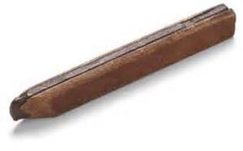In 1564, a graphite mine was found in Cumbria. The graphite was cut into sticks, the sticks were put into wooden holders – and the pencil was born. One pencil can draw a line 56 kilometres long. It can write about 45,000 words. Today, pencils are used by people all over the world.

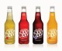********

**The Fizzy Drink**

Do you enjoy drinking fizzy drinks? You’re not alone. In the UK, the average person drinks 96.5 litres of fizzy drinks a year. The fizzy drink was invented by British chemist Joseph Priestly (1733-1804). Priestly found a way to put gases in liquids. He made the first glass of man-made soda water in 1767. Priestly didn’t know it, but he was changing the drinking habits of the world forever.

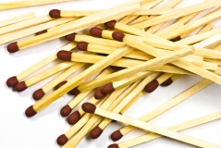**The Match**

Today, matches are found in every kitchen. They are used to light cookers, candles and campfires. The match was invented in 1826 by British chemist John Walker (1781-1859). Unfortunately, Walker did not patent his matches, so he didn’t get much money for this important invention.

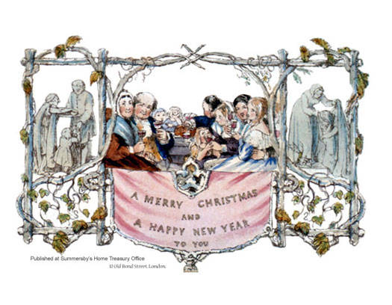 **The Christmas Card**

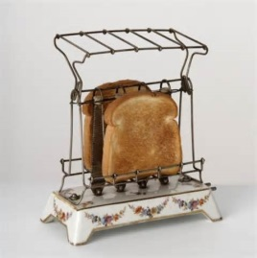Sir Henry Cole (1808-1882) was bored with writing letters to people at Christmas. In 1843, Cole paid an artist to draw a Christmas picture. Then he printed the picture on cards and sent them to all his friends and relatives. Cole realised he could make money from the cards. He made another 1,000 cards and sold them, and the Christmas card was born.

**The Electric Toaster**

Have you ever thought about the word “toast”? It comes from the Latin word “tostum” which means “to burn.” People have made toast for hundreds of years as a way of prolonging the life of bread. At first, it was made by toasting bread over an open fire. Then, in 1893, Englishman Rookes Evelyn Bell Crompton invented the first electric toaster. Unfortunately, his toaster wasn’t efficient. It only toasted one side of the bread.

**➌ WHICH INVENTION DO YOU THINK IS**

**THE MOST IMPORTANT? EXPLAIN IT.**

**➊ READ THE WEBPAGE. WHICH INVENTION IS IT?**

1. Slices of bread are put in it. 4. It was made from graphite sticks.
2. It is used to light candles. 5. It was invented in 1767.
3. It is sent to friends and relatives.

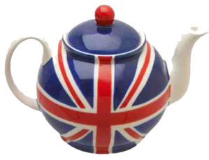

**➍ FIND THE WORDS ON THE WEBPAGE**

**TO MATCH THE DEFINITIONS BELOW.**

1. minerals are found there (lines 1-6)
2. normal, typical (lines 7-14)
3. things you often do (lines 7-14)
4. understood (lines 21-27)
5. effective, useful (lines 28-36)

**➋ ANSWER THE QUESTIONS. USE YOUR OWN WORDS.**

1. What is the connection between the mine in Cumbria and the invention of the pencil?
2. How did Priestly change the drinking habits of the world?
3. Did Walker become rich because of his invention? Explain.
4. Why did Cole make Christmas cards?
5. How was bread toasted before the invention of the electric toaster?

Задание – читаем информацию, письменно в тетради отвечаем на вопросы № 1, 2, 3, 4